# Setting and adjustment

## Users 1

The tab “Users” features all the adjustments to set up different access control for different users. The main reason for user access control is protecting the system. By limiting the user changing the configuration settings etc. the chance of disturbing system operation is limited as well.

Basically only three users are available. Administrator is the user status for Free Technics and its representatives. This login has all the rights available. This is logical because at commissioning and installation you need to be able to alter all the settings.

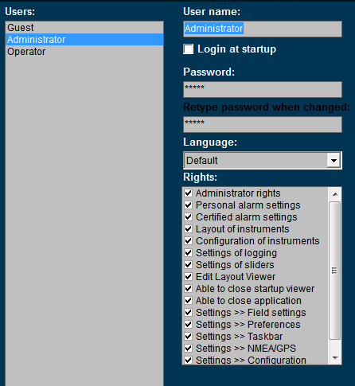

Figure 11‑1: Users

### User name

This is a box that shows the active user and his rights.

### Login at startup

Tick this box to set the default user at startup (default operator).

### Password

*: the user name “Administrator” is always password protected (standard this is “admin”).*

If a password is required please type password here. When changing the password or typing the password for the first time, retype password at next field “retype password when changed”.

### Language

In the box “Language” you can choose for “default” or “local”. If you choose “default” the main language will be English. By choosing “local” you can set any kind of language for the comments section. So the grouplabel, Item and label can be changed under fieldsettings/comments and it will be shown in the operators mode where you have chosen for “local” as language. If you change the default language to local, you will have to define the English language as well for that user in case you want to put it back again at a certain time. Default language always will be English.

In the Sensorlist it is possible to change these Local values as well. See the “sensorlist manual” for further details.

*: as of version FT NavVision© 3734*

### Rights

Rights can be set (by check mark) for each user. Rights are divided in several subgroups. Each user can have one or more rights. By putting a check mark you can set the rights.

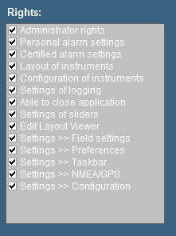

Figure 11‑2: Rights

|  |  |
| --- | --- |
| **Rights** | **Explanation** |
| Administrator rights | The right to change settings and user settings |
| Personal alarm setting | Set personal alarms directly in the instruments |
| Certified alarm setting | Set certified alarms in Field settings > Alarms |
| Layout of instruments | Change layout of instruments (i.e. unit, analogue-digital etc.) |
| Configuration of instruments | Change fields that instruments are representing |
| Settings of logging | Make logs of incoming data (see “Configuration > Field settings > log”) |
| Able to close application | Decides if the button to close FT is available |
| Settings of sliders | Allow setting of sliders in layout viewer |
| Edit layout viewer | Makes it possible to change the layout viewer |
| Settings > Field settings | Allows changing the field settings (see “Tools > Field Settings”) |
| Settings > Preferences | Allows changing the preferences (see “Tools > Preferences”) |
| Settings > Taskbar | Allows changing the taskbar (see “Tools > Taskbar”) |
| Settings > NMEA/GPS | Allows using “Tools > NMEA/GPS” tab |
| Settings > Configuration | Allows changing of configuration settings |

* **Administrator rights**All rights.
* **Operator rights**  
  Via “Setting > Preferences”, you are allowed to change time and language, ships heading reference and SMS service.   
  This can be extended with additional rights depending on what is needed.

*:   
Under “Operator rights” you will NEVER get the rights as mentioned below.*

* Administrator rights
* Certified alarm setting
* Configuration of instruments
* Settings of logging
* Settings of sliders
* Edit layout viewer
* Settings > Field settings
* Settings > Configuration

### Add / Remove

Via the “Add / Remove” buttons a user can be added or removed.

For example you need to add a user for the shipyard or the installation company. Click “Add” and fill in a new user name. For the removal of a user, click the user then click “Remove” and acknowledge.

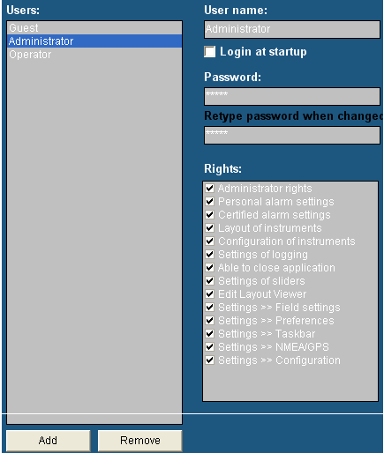

*:*

*Setup the new user direct at the beginning of the setup. In this way the user will get access to all settings and adjustments. If you set a new user after you’ve finished installing and adjusting the system, this will result in an empty user.   
All adjustments you’ve made are not visible. You can get the adjustments you made to appear in the new user by copying the content of the “administrator.ini” to the new user ini-file (i.e. shipyard.ini). For more information please refer to section “Adjusting ini-files”.*

Figure 11‑3: Add / Remove

1 Due to improvements and changes, this article will become obsolete. It will be removed as soon as the new changes take effect.